Lab 14 – My Solutions
1: Exercise 1. Deploy Enterprise Root CA:
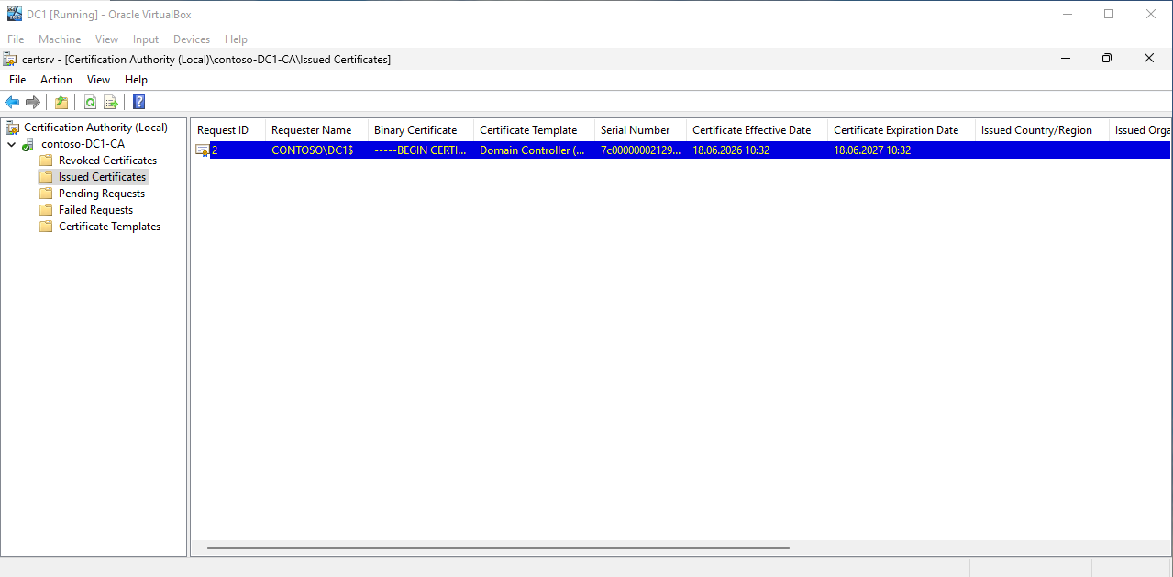
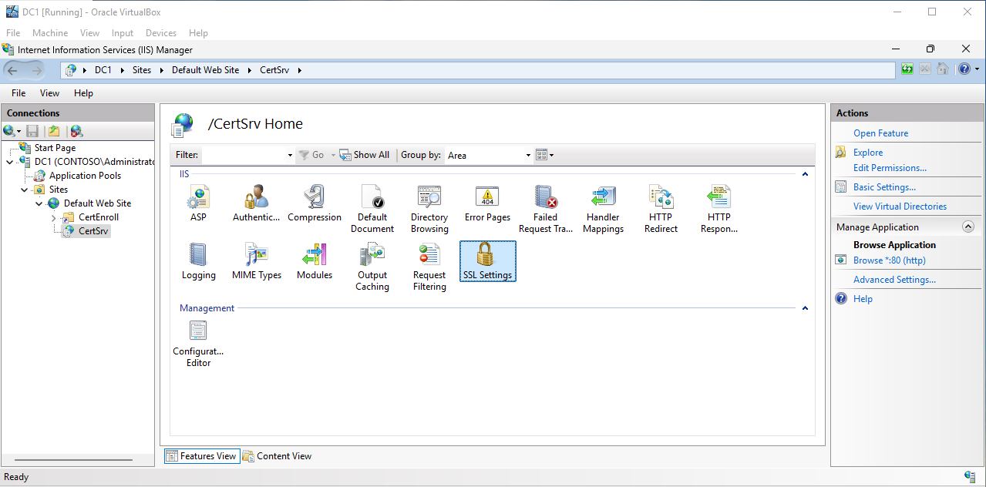
2: Exercise 2. Windows Firewall — Allow HTTP via Group Policy:
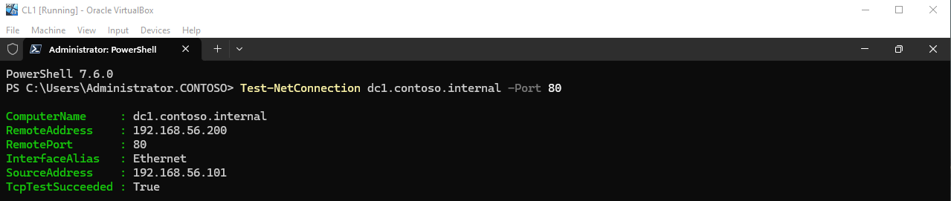
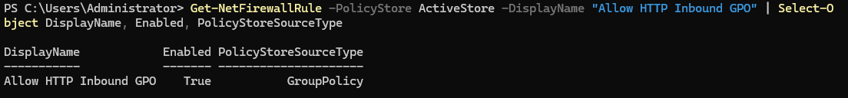
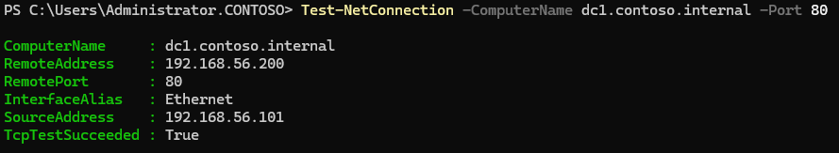

3: Exercise 3. Capture Cleartext Credentials with Wire‐shark:
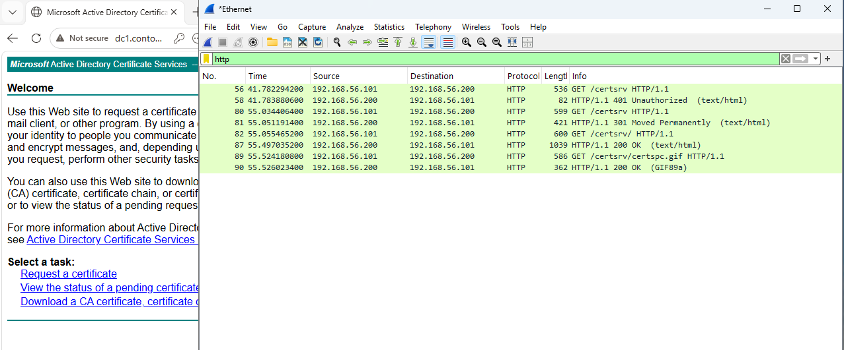
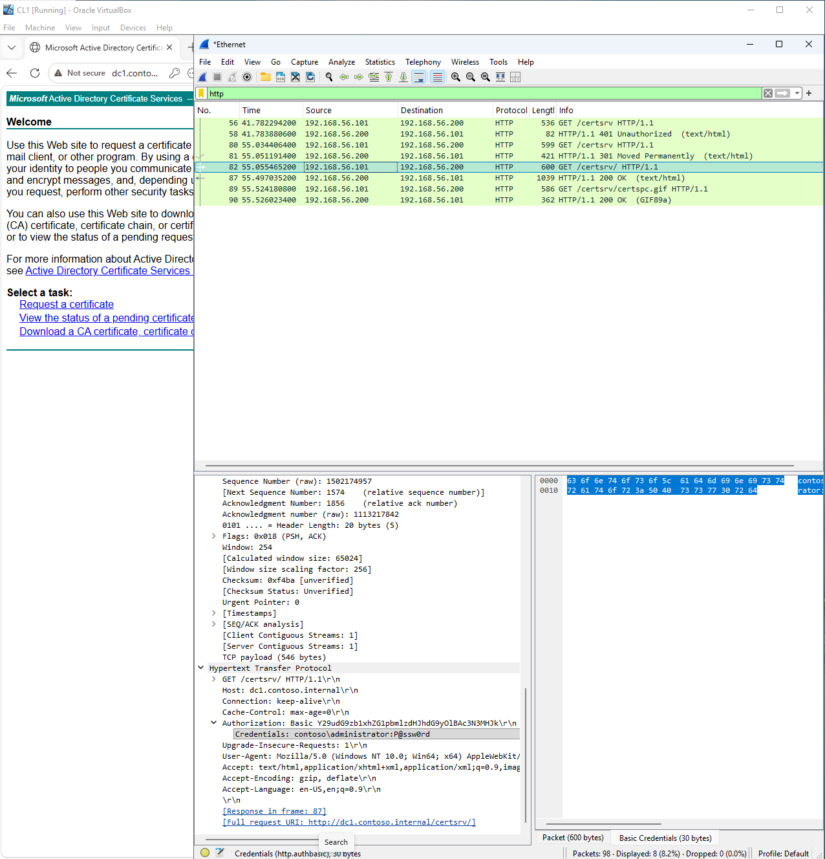
4: Exercise 4. Protect HTTP Traffic with IPSec:
